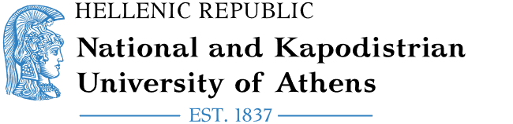Εικόνα που περιέχει γραμματοσειρά, σύμβολο, Μπελ ηλεκτρίκ, στιγμιότυπο οθόνης

Περιγραφή που δημιουργήθηκε αυτόματα

Erasmus+/KA171 International Mobility

Staff Mobility for Training

|  |
| --- |
| NAME OF THE STAFF MEMBER:  HOME DEPARTMENT:  TYPE OF MOBILITY: **Επιλέξτε ένα στοιχείο.**  RECEIVING INSTITUTION:  ERASMUS CODE (IF APPLICABLE):  RECEIVING DEPARTMENT:  ACADEMIC YEAR:  NUMBER OF TRAINING DAYS: **5**  FROM: Κάντε κλικ ή πατήστε για να εισαγάγετε ημερομηνία.  TO: Κάντε κλικ ή πατήστε για να εισαγάγετε ημερομηνία.  LANGUAGE(S) OF TRAINING:  NUMBER OF TRAINING HOURS (MIN. 8 HOURS PER WEEK):  [1]  [2]  ***This document serves to certify that the staff mobility was successfully carried out in accordance with the regulations of the Erasmus+ programme and in full alignment with the terms mutually agreed upon and outlined in the Mobility Agreement.*** |

CERTIFICATE OF TRAINING

**For the Receiving Institution**

[signature] [stamp]

[name / position]

Done at [place], [date*]

1. The above information must be completed by the participant and verified by the responsible person at the receiving institution.
2. The document cannot be signed before the last day of mobility