
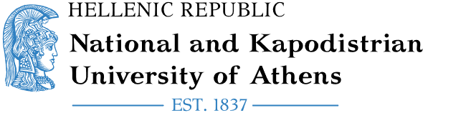
Erasmus+/KA171
International Mobility
Staff Mobility for Teaching

Department of European and International Relations
30, Panepistimiou Street, 106 79, Greece
erasmus@uoa.gr

NAME OF THE STAFF MEMBER:
HOME DEPARTMENT:
RECEIVING INSTITUTION:
ERASMUS CODE (IF APPLICABLE):
RECEIVING DEPARTMENT:
ACADEMIC YEAR:
NUMBER OF TEACHING DAYS: 5
FROM:
TO:
LEVEL OF STUDENTS ATTENDING THE LECTURE(S):
Undergraduate ☐
Postgraduate ☐
Doctorate ☐
LANGUAGE(S) OF INSTRUCTION:
NUMBER OF TEACHING HOURS (MIN. 8 HOURS PER WEEK):
CERTIFICATE OF TEACHING
This document serves to certify that the staff mobility was successfully carried out in accordance with the regulations of the Erasmus+ programme and in full alignment with the terms mutually agreed upon and outlined in the Mobility Agreement.
For the Receiving Institution

[signature] [stamp]
[name / position]
Done at [place], [date*]

The above information must be completed by the participant and verified by the responsible person at the receiving institution.
The document cannot be signed before the last day of mobility

