
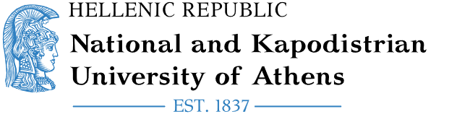
Erasmus+/KA171
International Mobility

Department of European and International Relations
30, Panepistimiou Street, 106 79, Greece
erasmus@uoa.gr

NAME OF THE STAFF MEMBER:
HOME DEPARTMENT:
RECEIVING INSTITUTION:
ERASMUS CODE (IF APPLICABLE):
RECEIVING DEPARTMENT:
TYPE OF MOBILITY:
☐Staff Mobility for Teaching (STA)
☐Staff Mobility for Training (STT) ► ☐Staff week ☐Job Shadowing
ACADEMIC YEAR:
NUMBER OF ACTIVITY DAYS: 5
FROM:
TO:
NUMBER OF ACTIVITY HOURS (MIN. 8 HOURS PER WEEK):
LANGUAGE(S) OF INSTRUCTION:
CERTIFICATE OF ATTENDANCE
For the Receiving Institution

[signature] [stamp]
[name / position]
Done at [place], [date²]
This document serves to certify that the staff mobility was successfully carried out in accordance with the regulations of the Erasmus+ programme and in full alignment with the terms mutually agreed upon and outlined in the Mobility Agreement.

The above information must be completed by the participant and verified by the responsible person at the receiving institution.
The document cannot be signed before the last day of mobility

